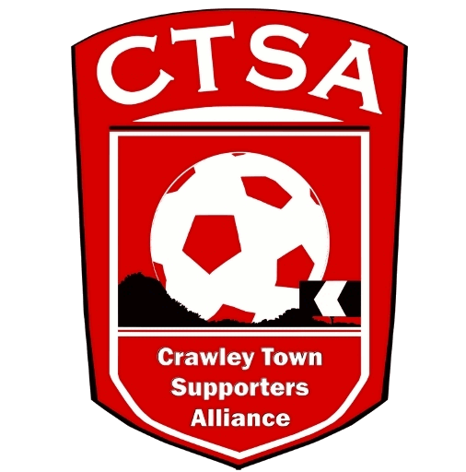 CRAWLEY TOWN SUPPORTERS’ ALLIANCE

Annual General Meeting Minutes – 22nd November 2017.
Redz Bar, Checkatrade Stadium – 8pm.

1. Welcome.

The meeting was opened by Carol Bates (Chair) who welcomed all attendees to this year’s AGM and thanked them for coming.

2. Apologies.

Apologies were received from Mick O’Donnell, Geoff and Ian Slater.

3. Confirmation of last year’s Minutes and any matters arising.

Last year’s AGM Minutes were approved.

4. Introduction and address by the Chair followed by the Vice-Chair.

CB started by confirming that she would be standing down from the Board as a Member and Chair at tonight’s AGM and went on to thank all CTSA Board members for all their support over the last 4 years. CB then went on to deliver her Chair’s Report. A copy of the Report is attached

CB then handed over to Vice Chair, Mat Cowdrey, who also advised that he would be standing down at tonight’s meeting. MC thanked everyone for their support and proceeded to deliver his Annual Report, which included details of the CTSA Fan Representative which had been agreed between the Board and the Club.

5. CTSA Fan Representative on the CTFC Board – Statements & Vote.

After hearing about the discussions over the last year between the CTSA and the Club, the CTSA was delighted that it had been agreed for a CTSA Fan Representative to be present at CTFC Board Meetings as well as regular Club Meetings. A donation of £8K has been made to the Club which covers for the first 2 years. The position would be reviewed annually and would be a Board position where the transfer of information from the Club and supporters would be open and transparent. It was confirmed that there were 4 candidates who had been nominated prior to the AGM, namely: Duncan Fennemore, Alain Harper, Sam Jordan, Steve Leake. The 4 gentlemen were asked to join the Board on the stage. As they had already given their Statements, which were available on the website, Members were asked if they had any further questions. Once the questions had been answered, the Vote took place. Members were asked to complete their voting forms and the final votes were counted as follows:

Duncan Fennemore = 1 vote
Alain Harper = 14 votes
Sam Jordan = 13 votes
Steve Leake = 14 votes
The vote resulted in a tie between Alain Harper and Steve Leake and at this point, before a second ballot was advised, Alain Harper offered to step down. This was not accepted by the CTSA Board and there was a second ballot. The votes were counted as follows:

Alain Harper = 15 votes
Steve Leake = 27 votes.

Steve Leake was congratulated on becoming the first CTSA Fan Representative and immediately joined the Board. Alain and the other candidates were also asked to join the Board. Sam Jordan accepted the offer and Duncan Fennemore and Alain Harper said they would think about making a decision, in the future.

6. Treasurer’s Report – Simon Smith.

SS tabled the accounts and re-iterated that the accounts/bank statements were always available to any member who wanted to look at them.

SS then went on to detail the accounts and advise that they would be audited after the AGM.

7. Report from Community Officer/Communications/Membership.

Details were given of the Community Events which were held throughout the season and it was hoped that the Football Festival would be held again in May 2018.

ML spoke about membership and communications.

8. Election of New Board Members.

CB stepped down from her role as Chair and MC stepped down from his role as Vice-Chair and both left the meeting, after thanking everyone.

The rest of the Board was then elected en mass, unanimously. Positions will be agreed at the next Board Meeting. The Board Members elected are as follows:

Sam Jordan
Steve Leake
Marilyn Loughton
Simon Smith
Andrew Tester

If there are any supporters who would like to join the Board or just help for a small amount of time, please get in touch.

9. AOB.

There was no AOB.

With no other business, the attendees were thanked for coming and the meeting was closed at 21.20 hrs.

