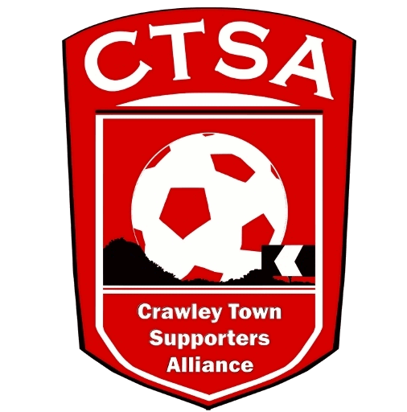 CRAWLEY TOWN SUPPORTERS’ ALLIANCE

BOARD MEETING MINUTES – 3rd October 2016.

Attendees: Carol Bates, Dan Charman, Mat Cowdrey, Marilyn Loughton, Andrew Tester.

1. Apologies.

Joe Comper, Simon Smith.

2. Confirmation of Minutes of last meeting and matters arising.

The Minutes were confirmed as an accurate record of the last meeting. DC has emailed Graham regarding the Crawley Hero nominations.

3. Chairman’s Report.

It was discussed regarding the difficulty as volunteers that, on occasion, Board Members working away or busy would be unable to get to meetings. It was suggested by MC that a written report would be accepted as attending by proxy. This was voted on and unanimously agreed.

The Cabin move was confirmed and the date set is for before the FA Cup game on 5th November. DC & CB to co-ordinate moving the signs and setting up in Redz, with Rhona. The Cabin needs to be cleared and anyone’s belongings will need to be returned to them.

The Macmillan Coffee Morning which was organised with Rhona, with help from AT & CB was a great success with the management and players attending. A total of £710.02 was raised.

4. Travel.

Hartlepool – Due to a lack of travellers booked on, it was agreed to hire a people carrier to take the small amount of supporters.

It was noted that an article on the G&H website contained a factually incorrect statement regarding our decision not to run a coach to Charlton. It was agreed that they be asked to amend the statement to contain the correct information. On the basis that there were people who wanted to travel to Charlton, it was agreed that we will run a coach to the EFL Trophy game at Southampton.

With regards to liaising with Clubs for away trips, MC asked if Barb Robinson was still in the SLO role. Doncaster Rovers and other clubs do a great job of informing details of forthcoming away games. There has been no official liaison with the CTSA and it was suggested that we speak to Barb to see which parts of the SLO role were being carried out.

ML will ask the Club to promote the Official travel a bit more on their social portals.

5. Community.

As JC was absent, CB explained a project that had been mentioned which helps people with mental health issues, which we could raise money for. In short, it is a photography course which is offered through an employability programme. JC will be able to give more details at the next meeting.

A Quiz Night was discussed and it was suggested that we could speak to Dermot and ask if the players could attend and join each table. January is probably the best time to run one and Wed. 11th was thought to be the best date. To be confirmed. CB/JC to speak to Rhona re. using the MWB Suite and DD to ask about the players attending.

Graham Wright has kindly given us 2 prs of tickets to the Ron Harris evening to give away in a Members’ Competition. Closing date for the Competition is 31st October and the winners announced on 1st November.

Tom Allman is to be contacted regarding the most updated list for the Loyalty Card members and any Junior Reds parents.

6. Finance.

Due to the absence of SS there were no accounts.

7. Communications/Membership.

DC has been plugging the Ron Harris Competition and has emailed the list of Members we have.

It was noted that communication with the crawleytownfc.com domain was not working from any of the ctfcsa email addresses. Thad to be contacted. ACTION DC
8. Constitution/FSF/SD.

There is a meeting in London at Supporters Direct, on 13th October which CB now can’t attend. DC to attend instead.

9. AOB.

It was suggested that we should ask for a CTSA Members Day to go and see the players train etc. as the DSA have previously done. This could be done in one of the school holidays and combined with Junior Reds/CTSA Members/Loyalty Card Members. The suggestion is to be brought up at the next Club Meeting.

There being no other business, the meeting closed at 20.55pm.

Next meeting – 7th November 2016 – 16 Herrick Close, 7.30pm.

CB – 05.11.16

