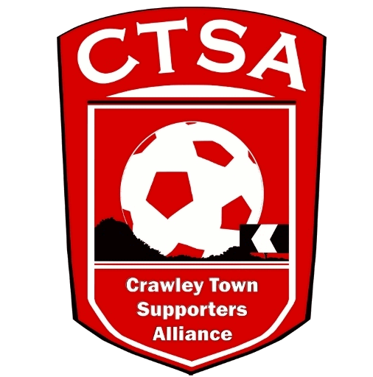 CRAWLEY TOWN SUPPORTERS’ ALLIANCE

BOARD MEETING MINUTES – 5th December 2016.

Attendees: Carol Bates, Dan Charman, Joe Comper, Marilyn Loughton, Simon Smith, Andrew Tester.

1. Apologies.

Mat Cowdrey.

2. Confirmation of Minutes of last meeting and matters arising.

The Minutes were confirmed as an accurate record of the last meeting. Portakabin details still to be passed to Bruce. Action now passed to SS.

3. Chairman’s Report.

A meeting was held with the Club and various issues were discussed. Notes have been issued. The Quiz has been booked for the 2nd February and will be in conjunction with Chestnut Tree House.

It was suggested that we could introduce a “100 Club” fundraising initiative whereby the 3 players who have reached their 100 game milestone could be Ambassadors for the Club and for a minimum fee (say £50 or £100) supporters could become a member and the funds would go straight to the playing budget. Needs more discussion but it was felt that this could be a good idea.

A Golf Day is also an event that will be looked into for March/April time.

It was also discussed that CTSA Members could have “an audience” with DD and MG for 30 minutes before any Fans’ Forums.

The future of the Official Travel was discussed and will be minuted under “Travel”.

End of Season CTSA Festival of Football has been booked for Friday 12th May.

4. Travel – including a discussion on the future of the Official Travel.

After many discussions at previous Board Meetings and talks with the Club, the Board unanimously voted (MC on conference call) that we would cease providing coaches for Official Travel, despite our best efforts to keep it going. Various factors have contributed to the non-running of viable coach travel and it was agreed that we would arrange a meeting with the Club and GH Coaches to talk about GH taking over the coach travel for the Club. This is very disappointing but there is no other alternative and the resource can now be used for fundraising. Leyton Orient will be the last trip that the CTSA provide coach travel for and from 1st January 2017, GH Coaches will take over, provided the Club are happy with the assurances given that all procedures are in place that have been requested by the Club. We wish GH Coaches success in running the coach travel for all supporters to get them to away games. ML has done an excellent job in trying to keep the travel going this season and thanks were given for all the hard work put in.

5. Community.

Details of the fundraising events for 2017 are stated in 3. above.

The Mental Health project that JC spoke about is still in its infancy and more of a long term plan so we will wait to hear further details.

6. Finance.

No change in the finances since last month. SS also reminded the Board that we made a decision at the end of last season to put approx. £5K aside to be used for investment in conjunction with our Aims and Objectives.

It is also clear that we need to make up some of the loss from the travel.

7. Communications/Membership.

DC stated that he was producing another Newsletter and asked for information to be sent to him. This will be issued in the New Year. ACTION DC

The notes from the SD Meeting are still to be issued. ACTION DC

We haven’t had any more Members since last month but we have had another nomination for a Crawley Hero. DC will be speaking to Bruce. With regard to a previous nomination, there was no reply from the first one.

8. Constitution/FSF/SD.

Nothing to report.

9. AOB.

JC stated that with a new baby due, he would probably find it hard to attend future meetings and asked if he should step down from the Board. The answer was no.

DC congratulated the COGS (Crawley Old Girls) on their recent FA Women’s Award.

There being no other business, the meeting closed at 20.45pm.

Next meeting – 9th January 2017 – 16 Herrick Close, 7.30pm.

CB – 27.12.16.

