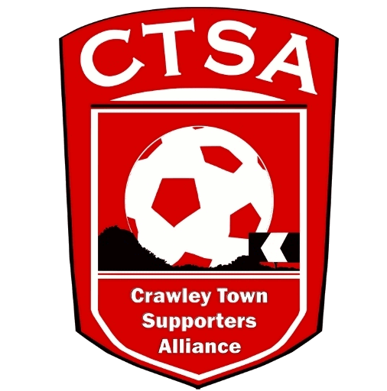 CRAWLEY TOWN SUPPORTERS’ ALLIANCE

BOARD MEETING MINUTES – 5th July 2016.

Attendees: Carol Bates, Dan Charman, Marilyn Loughton, Simon Smith.

1. Apologies.

Joe Comper, Mat Cowdrey.

2. Confirmation of Minutes of last meeting and matters arising.

The Minutes were confirmed as an accurate record of the last meeting.

3. Chairman’s Report.

Meeting was held with the Club on 8th June and notes have been produced. It was agreed that we would hold our AGM in conjunction with the Fans’ Forum, which has been provisionally organised for Tuesday 2nd August. Confirmation awaited from BT. SS will provide the accounts but will be unable to attend the AGM due to a trip overseas. Apologies were given in advance. Details of the AGM are to be posted on the website with the relevant documents and then on the social media portals. SS to put on the Forum. Early notification of the date is to be made, after a few requests from last year. Advise as soon as confirmation has been received.

It was agreed that the CTSA will provide the ball boys with tracksuits and t-shirts for the first League game and they will bear our logo and website address. Confirmation required from Birt as to sizes etc. ACTION CB

Mascots – For this season, the CTSA will run the mascot package for the Club. A timetable and package has been sent to BT and has been agreed. BT will put on the OS. BT passed over some red coats which can be used while the mascots are on the pitch. We need to get them printed with our logo and website address. Polo shirts also required. ACTION CB

The signs on the Cabin need to be removed, as they are worse for wear, and need replacing with new signs bearing the new logo. ACTION CB/DC

4. Travel.

Premier Transport, after 3 requests, didn’t send in any prices and therefore it was decided, after careful consideration, that we would use W&H Motors for the first games in August due to a large cost reduction compared with Clarkes Coaches. ML has been in communication with W&H and had a meeting where she had a look at the operation and the fleet. The first three games will each be £20 for adults and £15 for U16s. There will be no differential price for members and non-members. If the trips are trouble free, W&H will be asked to continue for the rest of the season. An announcement is to be made on the website re: the new coach provider. Posters/sheets also to be updated for the new season. ACTION ML
New travel tickets need to be ordered with the new logo but we will use the last few books of the old version before transferring to the new ones. Secprint produced the last books and have the proof so we will look at using them again. ACTION CB

ML has been organising a new contract for the travel phone. KB has been paid £90 for the annual tariff for last season.

Barb has passed over information from the company who provide coaches which include wheelchair spaces.

A trip to Bookers needs to be organised so we can get refreshments for the coach journeys.

5. Community.

A mascot timetable/package has been produced and sent to BT for authorisation by DD. It will be going on the OS, shortly.

The CTSA football team need new kit which will include the new logo and a sponsor has been found in PAF. Some of the money raised from the Supporters’ Tournament will go towards this kit. SS to provide for £200.

6. Finance.

The accounts for 2014/2015 have been audited and signed, ready to be sent off.

ML is in the process of setting up a PayPal account to be used on the website.

7. Membership.

The Club’s new Loyalty Scheme won’t be launched until 27th July so any new members will be advised of this before they sign up. There will be no concessional rates – just £5 for everyone. It was suggested that we could give new members a CTSA pen, if we have enough spare.

8. Constitution/FSF/SD.

No changes are due to be proposed at the AGM. New Board members will be requested in the AGM invite document.

9. Communications/Website.

The new website has now been loaded and just needs a few changes on the content. DC only had a few comments on the Newsletter email. All agreed that it looked good and we anticipate that it will be a bi-annual newsletter which will be available in the Club’s Reception area. DC also requested that we obtain a quote from the Club to include in the newsletter. ACTION DC

10. Board Positions – Season 2016/17.

It was agreed that we need to add a Secretary and another Board member. ML would also need some help with travel.

11. AOB.
SS stated that it had been agreed that Matt Butler would return to the Checkatrade, after the end of his FBO.

There being no other business, the meeting closed at 8.45pm.

Next meeting – 2nd August 2016 – AGM at Checkatrade.com Stadium.

CB – 16.07.16

