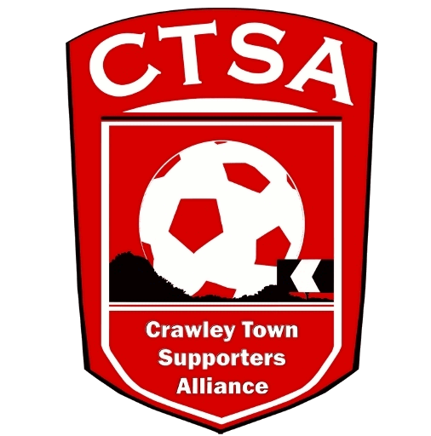 CRAWLEY TOWN SUPPORTERS’ ALLIANCE

BOARD MEETING MINUTES – 6th June 2016.

Attendees: Carol Bates, Joe Comper, Mat Cowdrey, Marilyn Loughton, Simon Smith.

1. Apologies.

Dan Charman.

2. Confirmation of Minutes of last meeting and matters arising.

The Minutes were confirmed as an accurate record of the last meeting.

3. Chairman’s Report.

It was with great sadness that we heard of the passing of Ian Hands and our sympathies go out to his family and friends. A real gentleman. Rest in Peace, Ian.

Since the last meeting, Sue had decided that she would no longer be part of the Board but would still help if needed. We would like to thank Sue for her work since she joined. We will ask for nominations for new Board Members at the AGM.

A very positive Club Meeting was held which included discussions on the CTSA taking on the mascots, reciprocal deals on away tickets for CTSA travellers, away travel deals, the new Loyalty Scheme and Matthew Butler’s FBO. Minutes have been issued. We offered to help the Club on match days by liaising with away fans to find out about their experience on a match day. The Club and the CTSA are working together well and this will benefit everyone.

The cheques for The Stroke Association and Chestnut Tree House are to be sent off and Ken also needs a cheque for £90 for the phone. All this to be done before the end of June.
ACTION CB

If anyone is available to attend the Supporters Direct Supporters’ Summit on the 16th July, that would be good as CB can’t make it.

The AGM date will hopefully be set by the next meeting, as the Club have agreed that we can have the AGM prior to a Fans’ Forum. Date to be advised in due course.

4. Travel.

Tenders were sent out to Clarkes, W&H Motors and Premier Transport. As soon as the fixtures are available a meeting will be held with the Club to discuss plans for the away travel. New incentives will be discussed. ML has been in contact with W&H and will be arranging a meeting to go and see their operation. Premier Transport promised prices by the 3rd June but they haven’t yet been received.

Community.

A mascot timetable/ package needs to be produced and sent to BT for authorisation by DD then we can go ahead and start advertising it. ACTION JC/CB

6. Finance.

SS stated that profit for the year would be around £208 after various payments had been made.

MC said that the accounts were being signed off that morning and he would have them back asap.

A PayPal account needs to be set up to be included on the new website. ML said she would be responsible for doing this. ACTION ML

7. Membership.

It was agreed at the last Club meeting that we would have one price of £5 for our Membership for the 2016/2017 season. The Club will be including our membership in with their new Loyalty Scheme. There will also be no differential price for travellers, with everyone paying the same amount.

8. Constitution/FSF/SD.

Supporters’ Summit is on 16th July if anyone wants to attend.

SS needs DC to sign one of the SD forms.

9. Communications / Website

We are nearly there with the new website and a meeting will be held with JT & DC to finalise the changes required.

The logo just needs some very slight changes.

10. AOB.

BT has passed on the red coats which will need printing up with the new logo and website address.

There being no other business, the meeting closed at 9.15pm.
.

Next meeting – 4th July 2016 at 8pm – 16 Herrick Close.

CB.

