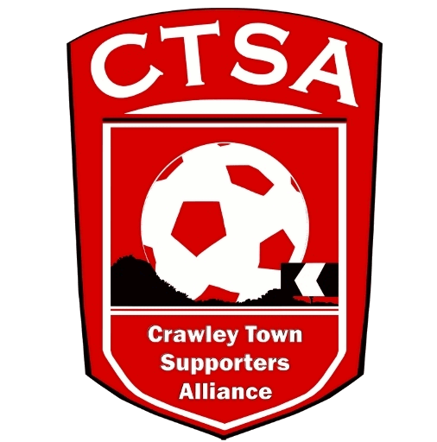 CRAWLEY TOWN SUPPORTERS’ ALLIANCE

BOARD MEETING MINUTES – 6th March 2017.

Attendees: Carol Bates, Mat Cowdrey, Marilyn Loughton, Andrew Tester.

1. Apologies.

Dan Charman, Joe Comper. Simon Smith.

2. Confirmation of Minutes of last meeting and matters arising.

The Minutes were confirmed as an accurate record of the last meeting, which was 9th January. February’s meeting was cancelled as only 3 Board Members were available.

3. Chairman’s Report.

CB re-iterated her statement, that was due to be given at the February meeting, that she intends to resign from the position of Chair and step down from the Board, at the end of season AGM (date to be confirmed). It had been an interesting and productive 3½ years but with the success of COGS and not having much spare time anyway, it was time to step down and pass on the reigns. A Statement will be issued and a new Chair will be sought. It was at this point that CB thanked all the Board Members for their help in the running of the CTSA, it certainly has had its ups and downs! CB will continue to run the mascot package with the Club and Community Foundation.

Mat Cowdrey also confirmed that he would be stepping down as Vice-Chair and from the Board, too and was thanked by CB for everything he had done. We will put out a joint Statement and make an appeal for new Board Members. ACTION CB

AGM date will be confirmed after discussion with SS.

MC then spoke about previous discussions on Fan Representation and will be in contact with Kelly Derham to discuss the issue further. Finer details to be discussed, in due course. ACTION MC

A final meeting, for the season, to be organised with BT and the Club with CB & MC included.

4. Community/Fundraising.

Unfortunately, the Quiz Night had to be cancelled due to another event, which had been arranged at short notice with no chance of changing the date and included some of the people organising the Quiz. There had been little response and therefore, only 2 teams had been let down. Apologies had been sent. New date to be set. ACTION CB

Efforts to be concentrated on the Festival of Football, which is to be held at the Stadium on May 12th. A schedule of tasks to be produced and help recruited. ACTION CB

DC to email members with upcoming events. ACTION DC

No acknowledgement had been received from the Community Foundation with regards to the bibs and tracksuits donated for the ball boys. Communication to be sent to Birt Kazim.

MC congratulated CB & the COGS on all the positive publicity for the Club that had been received over the last year.

6. Finance.

There were no updated accounts to table as there had been no activity since the last meeting.

MC said he would get the accounts passed off this week. ACTION MC

A question was raised by CB about the earliest date the accounts would be completed for 2016/2017 so that the AGM date could be announced. CB to speak to SS.

7. Communications/Membership.

Email to be sent out re. Quiz and upcoming events. We also need to get an up to date list of Loyalty Card holders from Graham Wright, to complete the Membership List.

8. Constitution/FSF/SD.

Date to be confirmed for this year’s AGM. ACTION CB

9. AOB.

ML asked what happened to the Kick It Out Day as there was no evidence that we took part in it. (After the meeting, it became apparent that KIO Day is now being held on 8th April).

MC stated that he would be riding from London to Amsterdam, for the 5th year running, in the EFL’s Annual Ride with Prostate Cancer. There will be a bucket collection by the turnstiles in March. Please give generously.

Raffle prizes: AT has offered to obtain raffle prizes for both the Quiz and Festival of Football. CTSA letter to be written and passed to AT. ACTION CB/AT

There being no other business, the meeting closed at 8.15pm.

Next meeting – 15th / 22nd May depending on attendance – 16 Herrick Close, 7.30pm.

CB – 26.03.17

