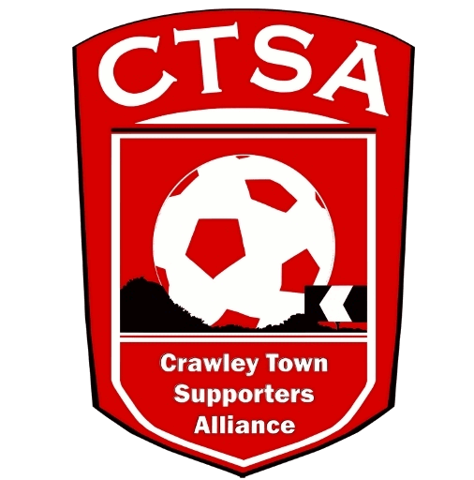 CTSA AGM – Chair’s Report – 22/11/18
Dear Members,
Welcome to the AGM and thank you for coming.

I would like to thank the current Board Members for their help over the last year and for all of their hard work that has gone on behind the scenes. We were especially grateful to all the supporters who supported with the Festival of Football where we raised over £1000 for various charities and to those who donated to this year’s Easter egg appeal (356 eggs).

We have looked at other avenues to see how we can raise money for the club, CTSA and charities. One of these was working alongside the betting company Fansbet where 50% of losing stakes would be given to the CTSA. This isn’t something that we are going to continue to push because only 7 supporters have a Fansbet account linked to the CTSA.

An initiative we are really passionate about pushing is Reds Rollover. The golden gamble that used to be in place generated significant funds for the supporters organisation and we feel Reds Rollover is the ‘modern’ version of this. It gives out 2 cash prizes and 2 prizes that are kindly donated by the club each month. We appreciate that the launch of this didn’t go as smoothly as we would have liked with registering and setting up a standing order etc. We will however be continuing with this and have recently had an advert placed in the matchday programme. In the new year we will review how we can make it more user friendly next season as this is going to be our main source of income which funds the Fan Representative on the board which I will come to shortly.

There is no requirement for an election this year but I am pleased to co-opt Mat Cowdrey back onto the board. We would really like to hear from anyone who has any ideas on how to raise the profile of the CTSA, the club and the charities we support as well as anyone who would be interested in joining the CTSA board. We have placed some role profiles on the website so supporters can understand what the role entails. We are particularly looking for individuals who can support us with our work in the community and someone, perhaps a student looking to add to their CV, who would like to look after our social media accounts. All Board Members are volunteers and any extra help is very welcome!

Last year Carol Bates and Mat alongside the CTSA board worked exceptionally hard to agree with the clubs board of directors that the supporters could have a fan representative on the board. This came at a cost of £8,000 for 2 seasons. Since then having been elected in that role Steve Leake attended a board meeting in March with Kelly and Selim. Since the close season concerns grew that we weren’t being invited to board meetings. Kelly would regularly meet Steve and I would often go too but we weren’t having dialogue with the rest of the board. After some perseverance Steve and I met with Kelly, Nuhkan and Selim a few weeks ago. The output of this meeting has been publicised on our website. Due to the lack of meetings in the last 12 months we asked for an extension to the agreement which was accepted. With this in mind we will be holding next year’s AGM before the start of the season so that the fan representative can be elected for the 2019/20 season.

One of the most important things the CTSA prides itself on is transparency. Any member, at any time, can ask to see the finances or talk to us about what we are doing. We are here to work on behalf of our members, so if you have anything you want to talk to us about, please don’t hesitate to contact us.

Sam Jordan
Chair

