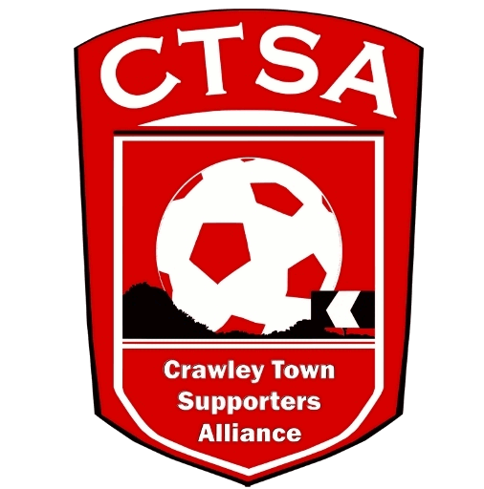 **CTSA AGM – Chair’s Report – 02.08.16.**

Dear Members,

Welcome to the AGM and thank you for coming.

We said last year that it had been a pretty testing time and although last season seems a while away already, it wasn’t without its challenges. I’m not going to dwell on the ownership issues or lack of communication with the CTSA but suffice to say that as soon as Mr. Eren had purchased the Club there was a very different ethos with regards to transparency, openness and a welcome approach to communicating with us. Long may it continue!

I would like to thank Sarah Moylan and Sue Benn for their contribution for last season and would welcome any new supporters who wish to get involved by way of being a Board Member or, just help on the odd occasion, on a sub-committee. I would also like to thank the current Board Members for their help over the season and believe we achieved many objectives together, including raising money for charity and a relaunch of the CTSA’s website. As we enter into the sixth year of the CTSA, you can now book your travel online, pay for your coach tickets via PayPal and also become a member by visiting the website. There are many other changes, which make it much easier to navigate. Our logo has also been updated and plans for the future will include a regular newsletter for members.

There has been a lot of work done behind the scenes, especially with our Community events and we were especially grateful to all the supporters who were involved with the Festival of Football and the 5th Anniversary Manchester United Quiz, where we raised over £1600 for various charities. We will continue to organise events this season and appreciate the support of fans and their families who attend them.

We have also had regular, productive meetings with the Club and are now working together on various projects, including the match day mascots and Crawley Heroes. We continue to support the Community Foundation with their projects and improve links with the local community for the benefit of our Club. If anyone wants to help us, please let us know. All Board Members are volunteers and any extra help is welcome!

As previously stated, one of the most important things the CTSA prides itself on is transparency. Any member, at any time, can ask to see the finances or talk to us about what we are doing. We are here to work on behalf of our members, so if you have anything you want to talk to us about, please don’t hesitate to contact us.

Like most supporters, we are looking forward to the coming season and hope that a good start will bring more people to the Checkatrade.com Stadium, as well as more people travelling to away games on our Official Travel supporters’ coaches. Please support us where you can.

Carol Bates

Chair.