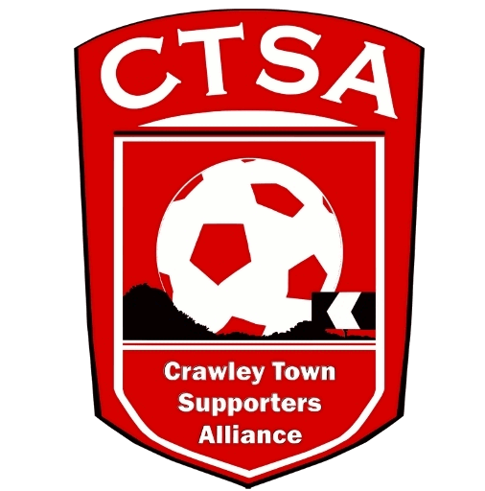
Crawley Town Supporters’ Alliance – End of Season Awards 2016/2017.
PLAYER OF THE YEAR 2017.
Player nomination: Player of the Year Vote (X)
Enzio BOLDEWIJN
James COLLINS
Jimmy SMITH
Lewis YOUNG
Mark CONNOLLY
Billy CLIFFORD
Glenn MORRIS
Bobson BAWLING
Joe MCNERNEY
Andre BLACKMAN
Josh PAYNE
Kaby DJALO

YOUNG PLAYER OF THE YEAR 2017.
Young Player nomination: Young Player of the Year Vote (X)
Enzio BOLDEWIJN
Mark CONNOLLY
Billy CLIFFORD
Bobson BAWLING
Kaby DJALO

Name………………………………………………………………………………….

Email form to chair@ctfcsa.co.uk or address to: Carol Bates c/o CTSA and leave at the Club’s Reception.
Closing date for votes is 30th April 2017.

