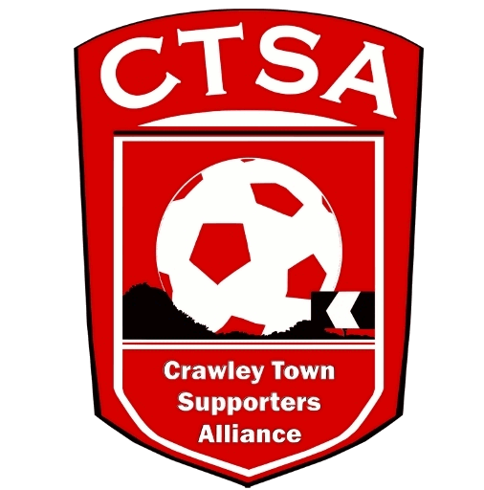 CRAWLEY TOWN SUPPORTERS’ ALLIANCE

BOARD MEETING MINUTES – 16th January 2018

Attendees: Sam Jordan, Steve Leake, Marilyn Loughton, Andrew Tester, David Leake, Chris Laker

1. Apologies.

Simon Smith

2. Confirmation of Minutes of last meeting and matters arising.

AGM – minutes have been prepared and will be on the website shortly

3. Election of Board Members

David Leake and Chris Laker were asked to join the board and both accepted and were welcomed by the members. Chris will assist with communications, on the website in particular, and David will be helping to get more schools involved with club

Alain Harper has declined to join the board. Duncan Fennemore has been approached and expressed an interest in attending a board meeting, but was busy with work commitments for this one. We hope to welcome him at a future meeting. Anyone else interested in helping out please get in touch

The constitution also allows for a club or player rep to be on the board – this will be pursued in due course.

4. Fan Representative.

Steve Leake has been meeting with Kelly Derham and others at the club and several questions raised by fans have been addressed – a report will be posted separately on our website in the near future. In the meantime Steve has given feedback from his meetings on the Crawley Town 4 Life Facebook group

A reminder that the new email account fanrep@ctfcsa.co.uk can be used to contact Steve with any issues supporters would like to raise. Steve’s next meeting with Kelly is scheduled for Monday 29th January

5. Finance

Nothing to report this month (SS absent)

6. Ideas for increasing Support

DL to look into establishing better links between more schools (in the local area and beyond) with the club

7. Fund raising

Discussions ongoing re:
Lottery/200 club style model – looking at feasibility and gauging interest
Junior Reds – club plans to relaunch – how can CTSA help?
Events around the World Cup – combine with season ticket sales/CTSA Membership launch for next year??

8. AOB.

Flowers were sent to the funeral of former coach Dermot Drummy which took place recently.

Next meeting – provisionally 27th February

ML

