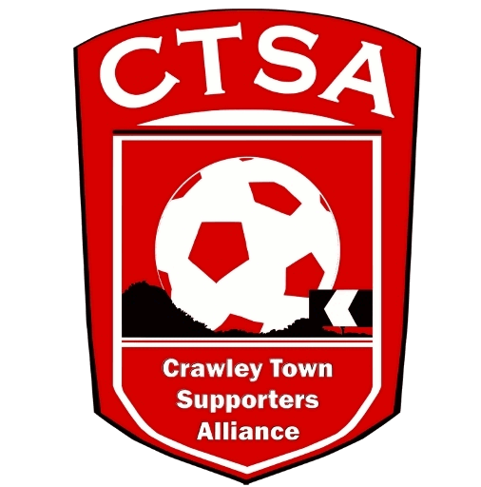 CRAWLEY TOWN SUPPORTERS’ ALLIANCE

BOARD MEETING MINUTES – 30th November 2017

Attendees: Sam Jordan, Steve Leake, Marilyn Loughton, Simon Smith, Andrew Tester.

1. Apologies.

None.

2. Confirmation of Minutes of last meeting and matters arising.

AGM – minutes to be prepared in due course.

3. Election of Officials

Sam Jordan was elected to the role of Chair.

Sam will approach Duncan Fennemore and Alain Harper to see if they wished to join the board. Steve to speak to Chris Laker and Dave Leake. Other interest would be welcomed.

The constitution also allows for a club or player rep to be on the board – this to be considered at a future meeting.

4. Fan Representative.

Steve Leake was elected to the position at the AGM. Congratulations were offered by the other board members.

A new email account fanrep@ctfcsa.co.uk to be set up.

Steve will make initial contact with Kelly Derham for an introductory chat. A number of initial areas for discussion were identified including:

End of season awards
Matchday prices
Next season’s kit
Junior Reds
Women’s football
Youth team
Finances/contingency plan if relegated
Position on stadium
Steve will agree with Kelly what can be shared in the public domain and situations where things will need to remain undocumented to protect the club’s interests.

We also need to agree a mechanism for members to raise questions and Steve to share information.

5. Finance

Little change since last meeting as the CTSA now has few ongoing expenses. £8,000 has been paid to the club for the supporter representative.

6. Galvanising Support

A general discussion took place around how CTSA could help increase the club’s support base. Ideas to be considered include:

More regular forums
Player engagement
Better use of mailing list and database of supporters

7. Fund raising

With money paid out for the supporter representative we need to look at ways of replenishing reserves. Ideas to be reviewed:

Golf day – Tilgate?
Lottery/200 club style model
Junior Reds
Events around the World Cup.

8. AOB.

The board noted with great sadness the sudden passing of former Head Coach Dermot Drummy. Flowers will be organised when the date of the funeral is known.

Next meeting – 9th January, subject to match arrangements.

SMS

