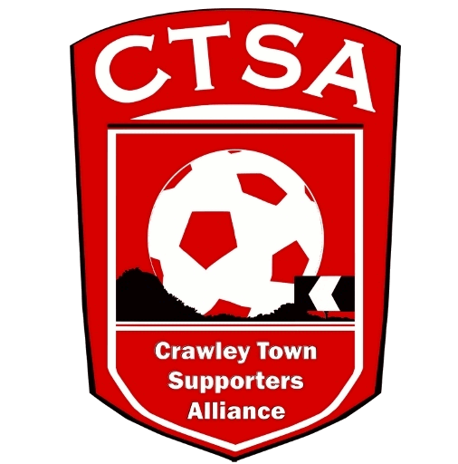
23rd October, 2017.
Dear All,
Crawley Town Supporters Alliance – Annual General Meeting – 22nd November, 2017.

As per the announcement on the CTSA website, I am writing to invite you to the Annual General Meeting of the Crawley Town Supporters Alliance, to be held in the Redz Bar at the Checkatrade Stadium, at 8pm on Wednesday 22nd November, 2017.

Please find enclosed the Agenda, last year’s Minutes and Form of Proxy. If you are unable to attend the meeting, please complete and return the Form of Proxy so your vote can be cast in your absence. The 2016/2017 accounts will be available to view on the website, in due course. Proxy forms can be returned to CTSA Chair, Carol Bates, 16 Herrick Close, Pound Hill, Crawley, RH10 3AN or emailed to chair@ctfcsa.co.uk.

At this meeting, we will update you on the work undertaken and our plans for the coming year as well as vote on the CTSA’s Fan Representative to attend Crawley Town FC Board Meetings. We will also formally elect new Board Members.

Current Board members, namely: Marilyn Loughton, Simon Smith and Andrew Tester will remain in their positions, while both Carol Bates (Chair) and Mat Cowdrey (Vice-Chair) will be stepping down from their positions on the Board.

As the Board can be made up of 12 candidates, there will not be a formal election. As previously agreed and voted on, our preferred maximum number is 8 and therefore, following the resignations of Carol Bates and Mat Cowdrey, we have 4 vacancies to be filled (one position will be held by the Fan Representative). We would welcome interest from anyone who wishes to step forward. The candidates will make themselves available for questioning by the Membership. Furthermore, if any members would like to be involved with the organisation and management of the Alliance, we can still co-opt them to sub-committees in a non-executive capacity and we would ask you to contact us. We would welcome any help you could give. The Statements, from the nominees, for the position of Fan Representative will be available after the closing date of 28th October.

Board roles are, in accordance with the Constitution, allocated by the Board once confirmed in post.

Please come along and let us know your ideas. We are here to act on behalf of you, our members. This is an opportunity for you to raise any ideas or concerns.

Please ensure your membership of the CTSA is up to date, if you wish to attend the AGM and vote.

Thank you for your support and we look forward to seeing many of you on the 22nd November. If you can’t make it and would like to raise any points or put forward any ideas, please email Carol Bates at chair@ctfcsa.co.uk.

Yours,

Carol Bates – Chair.

