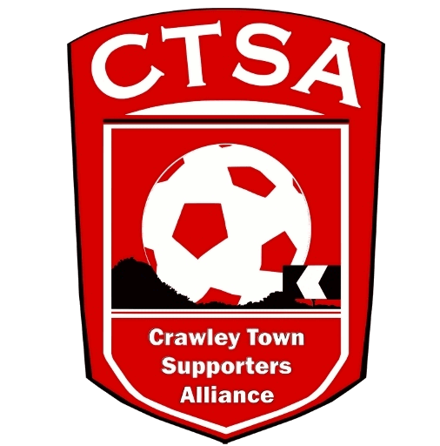 CRAWLEY TOWN SUPPORTERS’ ALLIANCE

Annual General Meeting Minutes – 2nd August, 2016.
Mayo Wynne Baxter Suite – 7pm.

1. Welcome.

The meeting was opened by Carol Bates who welcomed all attendees to this year’s AGM and thanked them for coming.

2. Apologies.

Apologies were received from the Treasurer, Simon Smith, who was away on business.

3. Confirmation of last year’s Minutes and any matters arising.

Last year’s AGM Minutes were approved.

4. Introduction and address by the Chair followed by the Vice-Chair.

CB thanked the past CTSA Board members for all their efforts and support and went on to deliver her address to the CTSA members. A copy of the Chair’s Report is attached. It was re-iterated how the Club is now supporting the CTSA since the arrival of Mr. Eren and this was much appreciated.

CB then handed over to Vice Chair, Mat Cowdrey, who also thanked the Club and Mr. Eren for their immediate support. MC then detailed some of the benefits that would now be in place for CTSA members.

5. Treasurer Report – Given by Mat Cowdrey in Simon Smith’s absence.

MC read out the Treasurer’s report (copy attached) and explained that discussions were ongoing re. Supporter Representation. The Club has been very welcoming and responsive. CTSA member Royston White asked how often meetings occur with the Club. MC stated that we have meetings every month/6 weeks depending on everyone’s availability but the relationship was very strong, with both formal and informal discussions taking place regularly. The accounts were tabled and unanimously voted to be accepted for the financial year 2015/2016.

As always, the CTSA maintain all records, an audit trail and receipts for all monies and the information of these accounts are open to everyone to view. The CTSA exists as a Limited Company and all Board members’ names are registered with the Financial Conduct Authority.

Further details of the breakdown of the accounts are included in the Treasurer’s Report.

6. Travel Report – Marilyn Loughton.

Unfortunately, not only did we have challenges last year in general but the away travel was particularly challenging, partly due to disappointing results and falling supporting numbers generally. There were a few occasions last season when we were unable to run a coach due to not being viable. As we do every year, we asked for quotes from other coach companies, this time focussing on more local businesses and were fortunate enough to have made a saving by returning to W&H Motors. ML went on to say that she had visited the Company and had seen the new fleet as well as met the new personnel. Having done all this, ML was confident they would provide us with a good service. The savings will give us more of a chance of taking coaches to longer away trips, due to the cost savings. These trips were not viable with Clarkes last season, due to the high costs. With the renewed optimism at the Club brought by the new owner and management team, and a more affordable travel package from ourselves, as the Official travel provider, we are hoping that CTSA away days will once again be filling up the coaches!

New initiatives are being brought in for CTSA travellers and we are working with the Club to try and offer reduced ticket prices on a reciprocal arrangement with opposing Clubs, for Official travellers. MC stated that, in general, the % of fans who travelled away on average is 10% of the home gate. CTFC are taking above that to many games despite the recent downturn. We are working with the Club to increase both home and away numbers.

7. Community – Joe Comper.

JC talked about the success of events that had been organised, especially the Festival of Football, which raised £1048 and thanked everyone who had contributed. Other events which raised money for charity included the 5 Year Anniversary Man Utd. Quiz Night which was sold out and attended by Club staff, the Community Foundation and special guest Sergio Torres, as well as plenty of supporters. That evening raised £632 for the Foundation to put into local schools’ coaching. A Supporters’ Tournament which was attended by the likes of Gillingham, MK Dons & Leyton Orient also raised £375. All events were run at the Club which also increased the Club’s income, through selling food and drink.

The CTSA, for the 2016/2017 season will also be taking on the running of the Mascot Package on behalf of the Club.

There will be events planned for this coming season so we hope they will be supported as well as the previous events have been.

Communications – Dan Charman.

Dan explained his role since joining the Board last year and spoke about the new website and its additional features. A Newsletter will be launched shortly which will be emailed to supporters and be available at the Cabin. The frequency is to be decided once it has been launched. If you have any content you wish to be included, please email DC on comms@ctfcsa.co.uk.

You will also have noticed that regular travel emails are being sent about forthcoming away matches, with information to improve your away day experience. This includes tips on where to drink and eat and purchase tickets etc. These have received some good feedback.

A new PayPal system has been introduced and was praised by members.

8. Election of New Board Members.

CB stepped down from her role as Chair and was duly re-elected by MC and seconded by Andy Tester.

The rest of the Board was then re-elected en mass, unanimously, and stands as follows:

Carol Bates – Chair
Dan Charman – Communications/Membership Officer
Joe Comper – Community Officer
Mat Cowdrey – Vice-Chair/Club Liaison
Marilyn Loughton – Travel Officer
Simon Smith – Treasurer/Constitution/SD/FSF

If there are any supporters who would like to join the Board or just help for a small amount of time, please get in touch.

9. AOB.

CB mentioned the new Loyalty Card that the Club would be launching and that this would include CTSA Membership. Membership could also be purchased separately via the website or at the Cabin for just £5 each per person. Forms are available to download on www.ctfcsa.co.uk or pick up, at the Cabin.

With no other business, the attendees were thanked for coming and the meeting was closed at 19.35hrs.

