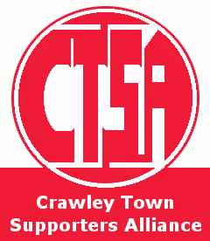
Crawley Town Supporters Alliance- End of Season Awards 2012/13

To be Presented in Redz Bar, Saturday 27th April from 6.30PM (following our match with Hartlepool United)
- all CTFC supporters welcome, the first team will be present
Player of the Year:

Away Travellers Player of the Year:
(Please vote if you've attended five or more away matches)
Young Player of the Year: Please choose from Mark Connolly, Connor Essam, Joe Walsh, Jamie Proctor, Aiden O'Brien, Jonte Smith, Lateef Elford-Alliyu
Please vote only once- we're relying on your honesty!

