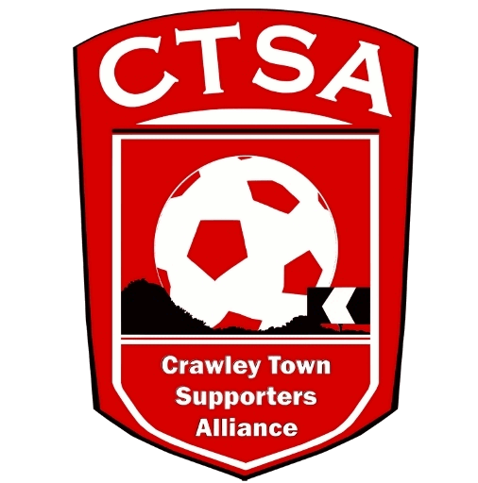 CRAWLEY TOWN SUPPORTERS’ ALLIANCE

BOARD MEETING MINUTES – 5th September 2016.

Attendees: Carol Bates, Dan Charman, Mat Cowdrey, Marilyn Loughton, Andrew Tester.

1. Apologies.

Joe Comper, Simon Smith.

2. Confirmation of Minutes of last meeting and matters arising.

The Minutes were confirmed as an accurate record of the last meeting.

Prior to Item. 3., Andrew Tester was unanimously voted on to the Board.

3. Chairman’s Report.

The Mascot Package was discussed with the Club at the last meeting, as it was felt the initial look at the price of £125 may put people off, without them realising it includes 4 West Stand tickets. Also, some people may already have season tickets so it was felt that the price would just cover the package itself without any tickets. Away mascots will be done on a reciprocal basis.

A meeting was held with Graham & Rhona about the Coffee Morning, and the plans needed to put it in place.

An informal discussion was held with the Club regarding the use of our Portakabin and after further formal discussion, it was agreed that the Club will take over our Portakabin to use as a storage area as well as selling small cash items on match days. We would then move into a space in the Redz Bar (by the brick wall) to sell the travel and membership etc. Signs would be moved and put up on the wall and the brick wall. A date needs to be agreed for the completion of the change. The Portakabin needs to be emptied out. It was felt that this would be beneficial to both of us as we would now be in the vicinity of the supporters rather than stuck in the car park area.

Crawley Heroes has now been advertised and DC has already had a couple of nominations. These are to be followed up. ACTION DC

A suggestion was made in the Club Meeting that we could maybe organise a Footgolf Charity Day, which will include players, staff and fans, as per the previous Golf Day. This would raise funds for charity. A meeting will be arranged to discuss the idea further.

It was also suggested that we have an End of Season POTY Evening. This will be looked at nearer December time.

4. Travel.

Well done ML on your efforts to get the coach filled for Portsmouth. There were quite a few new travellers and hopefully they will travel again with us. Thanks to Ken for stewarding. We are taking a few losses on travel this season, more than the £100 we agreed. As we go through the season we will hopefully build up the number of people travelling and try and make up the deficit.

A special coach ticket and match ticket price has been agreed for Morecambe and this will hopefully enable us to take a coach with a minimum loss. This needs to be constantly advertised.

It was agreed that with the historical low numbers of supporters who want to travel on a Tuesday evening, coupled with the train price and proximity of Charlton that we would not run a coach to the EFL Trophy game. As well as many supporters boycotting the Cup, it was agreed that this could well end up with another big loss and therefore, it would not be viable to run one.

5. Community.

We have had some extremely positive feedback from the Mascot Package and with the support of Dermot, Matt and the players, this has really made the mascot experience a special one.

Tracksuits have been given to the Community for the ball boys and we are just waiting to get the bibs printed up. This has taken longer than first anticipated, due to other priorities.

6. Finance.

Due to the absence of SS there were no accounts.
ML has set up the PayPal account and it seems to be working really well, especially for receiving Membership payments.

7. Communications/Membership.

Memberships are still coming in and it was discussed that we laminate cards to save money. Post meeting the balance of the previous cards were found in the Cabin. Although, still with the old logo, we should use these. DC has had some good feedback on the Newsletter. An email will be sent out about upcoming events ie. Coffee Morning and travel.

8. Constitution/FSF/SD.

Nothing to report.

9. AOB.

There being no other business, the meeting closed at 9.25pm.

Next meeting – 3rd October 2016 – 16 Herrick Close, 7.30pm.

CB – 30.09.16

