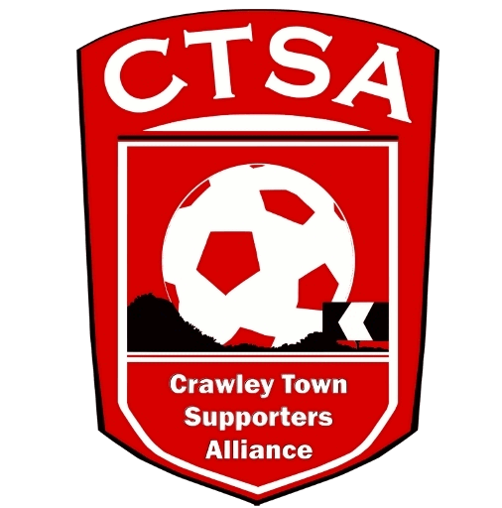 CRAWLEY TOWN SUPPORTERS’ ALLIANCE

BOARD MEETING MINUTES – 7th November 2016.

Attendees: Carol Bates, Marilyn Loughton, Andrew Tester.

1. Apologies.

Dan Charman (late meeting), Joe Comper (late hospital visit), Mat Cowdrey & Simon Smith (delayed until too late, due to train incident).

Due to the above reasons there were only 3 Board Members attending but it was decided to still go ahead with the meeting.

2. Confirmation of Minutes of last meeting and matters arising.

The Minutes were confirmed as an accurate record of the last meeting.

3. Chairman’s Report.

The Cabin move was completed, to the Redz Bar, for the FA Cup game on 5th November. We would like to pass on our thanks to DC’s Father-in-law, John Fillary, for his help in putting up all the signs in Redz. We are still in possession of some keys to the Cabin, which Darren Hands is aware of and it was agreed we would keep our travel signs and filing cabinet in there, in the corner. Paul Prendergast has been asked to remove his bags with his bell and rattle etc. in them. The standing order arrangement will need to be passed on to the Club. CB to pass details to Bruce. ACTION CB

A meeting is to be arranged with the Club before the next meeting. ACTION CB

4. Travel.

With the accounts SS had issued before the meeting, the travel is showing a loss of £320 on top of the £920 Cabin costs. It was thought that without the Cabin cost, it was possible to re-coup the sole travel loss before the end of the season but signs were that there are just not enough people travelling with us at the moment. A good Cup run would make a difference and further discussion is required on the future of the travel.

A coach was booked for the Southampton Checkatrade Trophy game after discussion re. the Charlton game but unfortunately this had to be cancelled due to lack of interest.

Cruisers had been contacted for prices for smaller vehicles but they weren’t much cheaper. W&H have also said that they want 7 days’ notice for cancellation of any coaches as we have been booking them and cancelling a few days before the day of travel.

5. Community.

We would like to congratulate Gary Thompson and Geoff Thornton who both won a pair of tickets each to the Ron “Chopper” Harris. Thanks to Graham for supplying. We also have a photo of Ron to auction.
The Quiz needs to be booked. ACTION CB

Various fundraising ideas and events were discussed and these need to be taken further in a separate meeting.

The mascot packages were continuing to get good feedback and more were being booked.

It was suggested that we could maybe do something for Crawley’s Open House. ie. A Christmas Appeal?

6. Finance.

SS issued the accounts prior to the meeting and these were tabled. Losses as already stated in 4. Travel. Fundraising efforts will be needed to reduce the losses.

7. Communications/Membership.

DC issued a proxy report as he would be held up in a meeting. He has been speaking to Bruce T. about MC’s nomination for Steve Hoffman of Crawley United. Steve was nominated for his volunteering in the local community with Crawley United and The Oaks School for coaching young girls and boys with the great ethos of development. Steve takes on the new U6s/U7s every season and installs this ethos in the group each season ready for them to go to the next year. Steve also gives up a lot of time to coach a disabled team as well as coach girls after school. He is also Chairman of Crawley United and does a tremendous amount of work behind the scenes. Bruce said it would be good to get members from Crawley Utd FC, kids, family, friends etc to do a ‘guard of honour’ a small presentation on a match day of his choosing (a couple of exceptions given) and then him and one other will enjoy hospitality.

A second newsletter is being compiled and some information from Community and details about the mascot feedback would be welcome so it can be produced for the end of the month.

One idea DC would like to put before the Board is in addition to our newsletter we start doing a Q&A piece with management and staff, this would be in the format of asking our members to put forward questions to a ‘selected’ player / member of the management team every other month. This would be a good fan engagement piece and something which would be well received by then fans. It was agreed that this was a good idea.

There were still a couple of Memberships coming in but it had now slowed right down. An updated membership list should be obtained from Tom Allman at the Club.

8. Constitution/FSF/SD.

DC attended a meeting in London at Supporters Direct, on will issue some notes on an interesting evening. ACTION DC

9. AOB.

There being no other business, the meeting closed at 20.45pm.

Next meeting – 5th December 2016 – 16 Herrick Close, 7.30pm.

CB – 03.12.16

