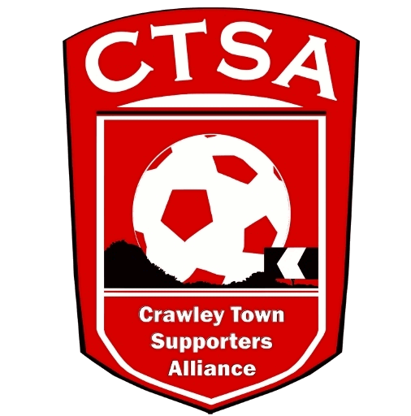 CRAWLEY TOWN SUPPORTERS’ ALLIANCE

BOARD MEETING MINUTES – 9th January 2017.

Attendees: Carol Bates, Mat Cowdrey, Marilyn Loughton, Simon Smith, Andrew Tester.

1. Apologies.

Dan Charman, Joe Comper.

2. Confirmation of Minutes of last meeting and matters arising.

The Minutes were confirmed as an accurate record of the last meeting.

3. Chairman’s Report.

The Board were sad to hear of the passing of long time Crawley fan, Ted Covey and our sympathies were passed on to Chris. Ted’s funeral is being held on 10th January, then afterwards in the Redz Bar.

After relinquishing the travel, the Aims and Objectives of the CTSA were re-visited and it was agreed that the main focus of the Board, going forward, is to begin discussions with the Club regarding Supporter Representation. MC to arrange a meeting and discuss further with the Club. It was suggested, should this happen in the future, that any fan could be nominated to be the future Representative but they would have to be a member of the CTSA and then a vote would be taken by members. ACTION MC

It was noted that some members had asked about their details being given to GH Coaches with reference to emails they had received from GH after the official travel had been handed over. It was confirmed that no Board members had passed on any members’ details.

CB confirmed that the handover of the travel to GH Coaches, from January 1st, had been a smooth transition.

4. Conclusion of the Travel.

The last trip to Leyton Orient was a successful one and, as stated above, the transfer of the travel to GH Coaches on the 1st January, was completed. A massive “thank you” went to Marilyn, who has worked really hard to keep the travel going and this was echoed by everyone. With the handover now complete, the Cabin details have also been passed over to the Club and the monthly rent paid directly by CTFC.

5. Community.

It was agreed that we would try and put together three events this season to raise money for local charities and the Community. The first one being the Quiz, then a Golf Day and finally the CTSA Festival of Football. The Golf Day will require a lot of organising so that needs to be discussed with the Club, asap. The second Festival of Football tournament will take place on Friday 12th May, at the Stadium.

Ball boy tracksuits were handed to the Community department and the question was raised as to whether they were being used, as they didn’t seem to have been used, so far. The bibs are in the process of being printed and when they have been completed they will be passed to Scott Bratt and a pitch side photo/handover is to be done. Check with BK what’s happened to the tracksuits. ACTION CB

It was suggested that the 50/50 be resurrected, as this would earn money for the Club and the CTSA. The tickets are still in the Cabin and it will need at least 4 people to run it to make it run successfully. CB stated that she didn’t have time to run it as she was now looking after the mascots and that it would need someone to give up their match day to ensure it was run properly. ML offered to help. Commitment from more people would be needed on a regular basis. Item to be reviewed before the next meeting. The Lottery Licence needs to be up to date.

It was also suggested that perhaps we could sell football cards in the Exec. Suite on a match day. This is also to be followed up.

6. Finance.

The last trip to Leyton Orient, ensured that the travel finished on a break even basis, without the Portakabin costs of approx. £900. This will need to be raised, in order to cover the loss.

The Accounts have been signed off and given to MC.

7. Communications/Membership.

Nothing to report as DC is travelling for the next month.

8. Constitution/FSF/SD.

Nothing to report.

9. AOB.

The Premier League’s FSIF has issued details of a Fans Fund Small Grants Scheme to help improve the relationship between a Club and its fans. It was discussed and agreed that this is not something that is needed at the moment.

CTSA phone – now we are no longer looking after any travel, do we still need to keep the travel phone? It was stated that we can still use the number for communication regarding community events, so yes, we will keep it.

There being no other business, the meeting closed at 8.40pm.

Next meeting – 6th February 2017 – 16 Herrick Close, 7.30pm.

CB – 12.02.17 – Meeting postponed until 13th February.

