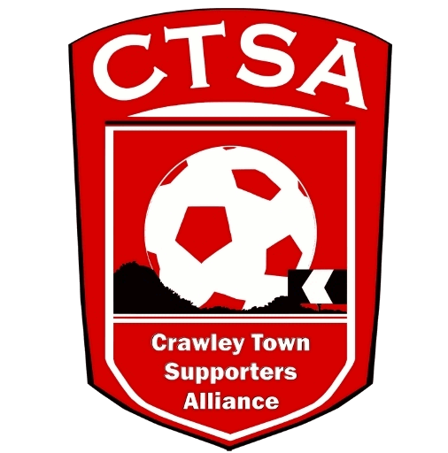 PLAYER SPONSORSHIP FORM
“A FESTIVAL OF FOOTBALL”
6-A-SIDE CHARITY EVENT FOR REDS’ FANS
6.30PM - FRIDAY 10TH MAY 2019 – THE PEOPLE’S PENSION STADIUM.

A minimum of £20 per player is to be raised and given at Registration, on 10th May.

Player Name…………………………………………. Team …………………………………………..

Name Address Amount Paid
Total raised
Grand Total

