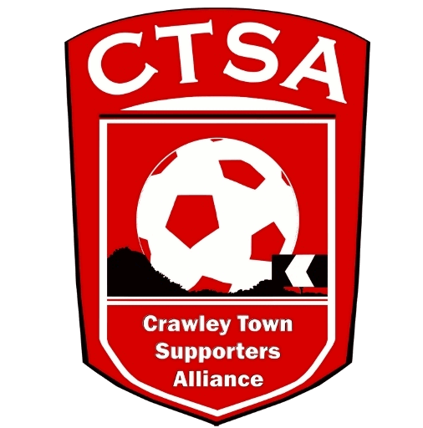 PLAYER SPONSORSHIP FORM.
“A FESTIVAL OF FOOTBALL”
6-A-SIDE CHARITY EVENT FOR REDS’ FANS
6.30PM - FRIDAY 12TH MAY 2017 - CHECKATRADE STADIUM.
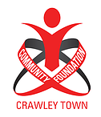
A minimum of £20 per player is to be raised (including £10 deposit paid to reserve entry) and the rest will be collected at Registration, on 12th May.

Player Name…………………………………………. Team …………………………………………..

Name Address Amount Paid
Total raised
Grand Total (less £10 dep. If pd.)

