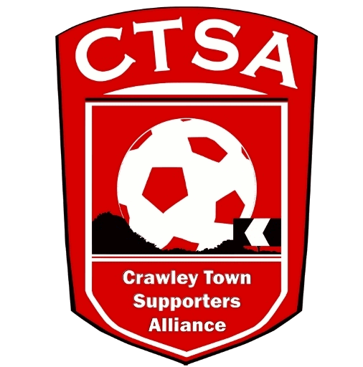 PLAYER SPONSORSHIP FORM
“A FESTIVAL OF FOOTBALL”
6-A-SIDE CHARITY EVENT FOR REDS’ FANS
3.00PM - SUNDAY 21st MAY 2022 – THE BROADFIELD STADIUM.

A minimum of £20 per player is to be raised and given at Registration, on 21st May.

Player Name…………………………………………. Team …………………………………………..

Name Address Amount Paid
Total raised
Grand Total

