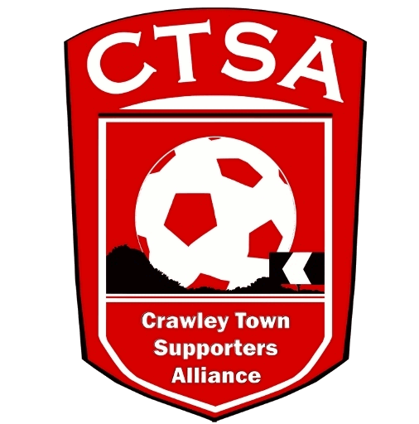
“A FESTIVAL OF FOOTBALL”
6-A-SIDE CHARITY EVENT FOR REDS’ FANS
6.00PM - FRIDAY 12TH MAY 2017 - CHECKATRADE STADIUM.
TEAM ENTRY FORM.
All adult supporters are welcome to play in the Festival of Football. The Team Organiser should be a Crawley Town ST Holder/CTSA Member/Regular Supporter.
To reserve your team’s place, please email a copy of this form to chair@ctfcsa.co.uk with your min. 6 team members/deposit (we will organise collection of the deposit), or give the form & deposit to Clare James in Reception. The final copy of this form will be handed in, on the night.
Teams should be made up of between 6 & 8 players, including at least 2 men and 2 women. The rest is up to you!
Team Managers will need to register your teams by 6.30pm and a Managers’ Briefing will be held at 6.45pm. Games will kick off at 7pm. Rules and match details will be given out at Registration.
If you have any questions, please email chair@ctfcsa.co.uk
Team Name: ……………………………................... Team colours: ………………………………..

Player’s Name Dep. £10 pd. Y/N Total Raised* Received
1
2
3
4
5
6
7
8
*including £10 deposit.
Team Organiser Name:………………………… Signature …………………………
I have received a copy of the timetable/rules & understand that players on my team play at their own risk.

Sponsorship received by CTSA – Date/Signature ……………………………………………

