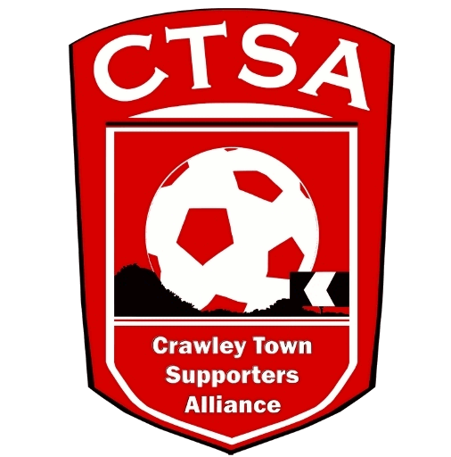
“A FESTIVAL OF FOOTBALL”
6-A-SIDE CHARITY EVENT FOR REDS’ FANS
3:00PM - SUNDAY 21st MAY 2023 – THE BROADFIELD STADIUM.
TEAM ENTRY FORM.
All adult supporters are welcome to play in the Festival of Football. The Team Organiser should be a Crawley Town Season Ticket Holder, CTSA Member or regular Supporter.
To reserve your team’s place, please email a copy of this form to redsrollover@ctfcsa.co.uk with your minimum 6 team members by Thursday 18th May. The final copy of this form and all sponsorship money will need to be handed in on the night at registration.
Teams should be made up of between 6 & 8 players, including at least 2 men and 2 women. At any one time, whilst playing, there should be a minimum of 2 men and 2 women playing. The rest of the team is up to you!
Team Managers will need to register your teams by 3:00pm and a Managers’ Briefing will be held at 3:15pm. Games will kick off at 3:30pm. Rules and match details will be given out at Registration.
If you have any questions, please email redsrollover@ctfcsa.co.uk
Team Name: ……………………………................... Team colours: ………………………………..

Player’s Name Money received
1
2
3
4
5
6
7
8

Team Organiser Name:………………………… Signature …………………………
I have received a copy of the timetable/rules & understand that players on my team play at their own risk.

Sponsorship received by CTSA – Date/Signature ……………………………………………

